Feed-Forward Neural Network
AIM:
To write a Python program to implement a Feed-Forward Neural Network for processing inputs and producing outputs.
ALGORITHMS:
- Start.
- Import the required libraries.
- Initialize the input data and target output.
- Initialize weights and biases randomly.
- Perform forward propagation using the sigmoid activation function.
- Calculate the output error.
- Update weights and biases using backpropagation.
- Repeat the process for the specified number of epochs.
- Display the final predicted output.
- Stop.

CODE:
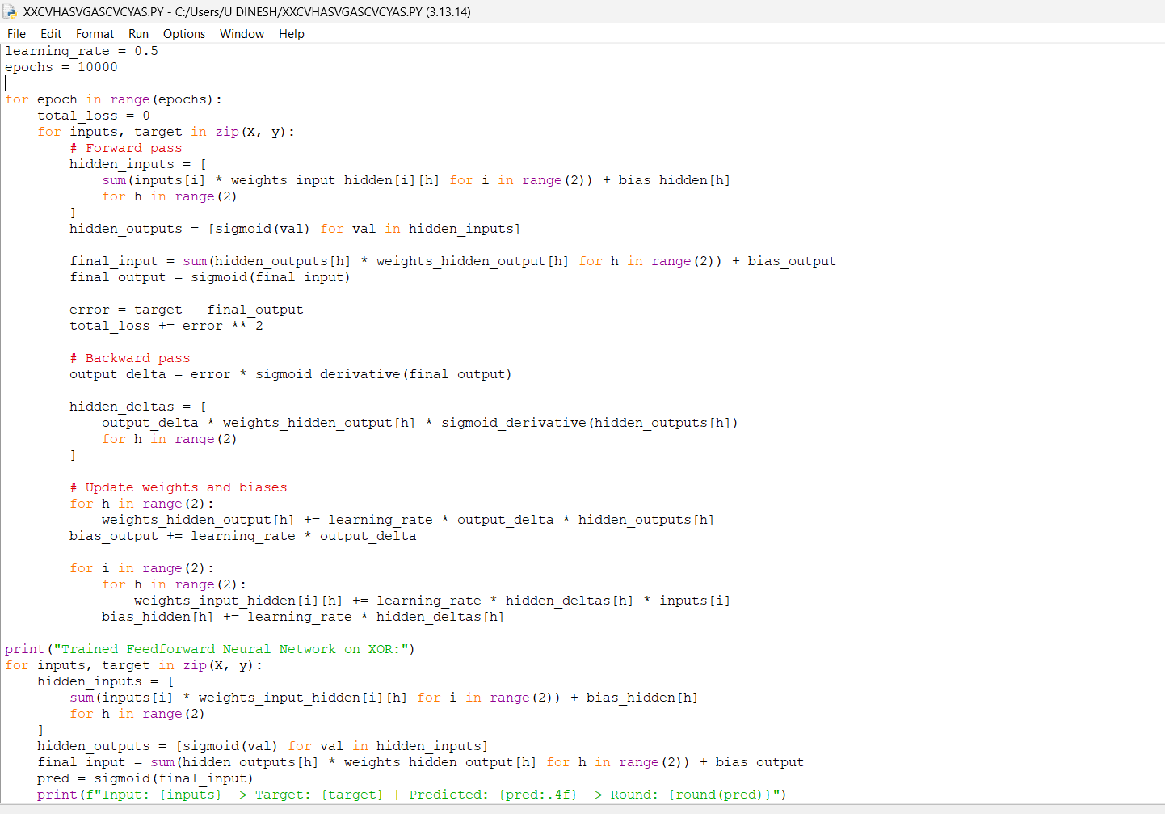
OUTPUT:
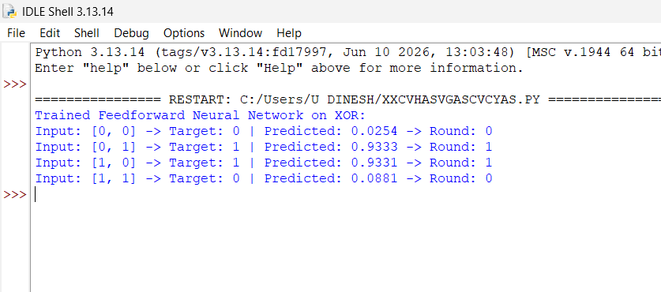

RESULT:
Feed-Forward Neural Network: The neural network processes the input through hidden layers and produces the predicted output.

